Search

David Murphy
11 August Development

An Intro Into TestFlight: Internal Testing

TestFlight is completely optional, yet completely free for all iOS developers

All data is invaluable to your app's success; hence, aggregating information about apps pre­release has become part of the norm. Two types of beta testing exists; internal (closed) and external (open). Last time, we reviewed how to setup External Testing;

now, let's focus on the Internal alternative.

If you need any help deciding which method of testing to use, click here and decide first before proceeding. Prerequisites to setting up Internal Testing:

­ An iTunes Connect Record

­ Potential testers that are assigned with the Admin, Technical, App Manager, Developer, or Marketer role
­ A pre­uploaded build of your app

Login to your iTunes Connect page and select My Apps

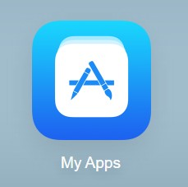

Open the Activity tab on the upper­most pane and scroll down to select the build to be tested; select the proper Version and Build
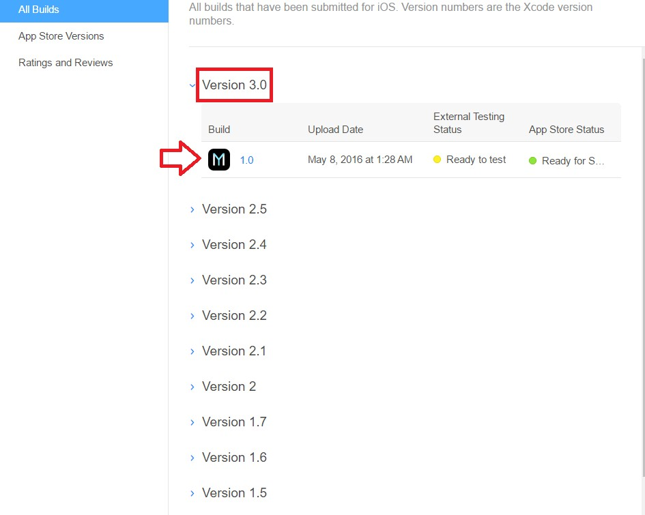
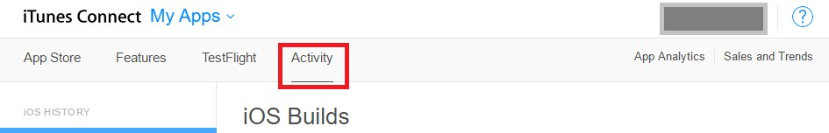

Click Test Information and leave instructions for testers to follow in What to Test. Provide other information for testers such as Beta App Description, Feedback Email, and any other URLs
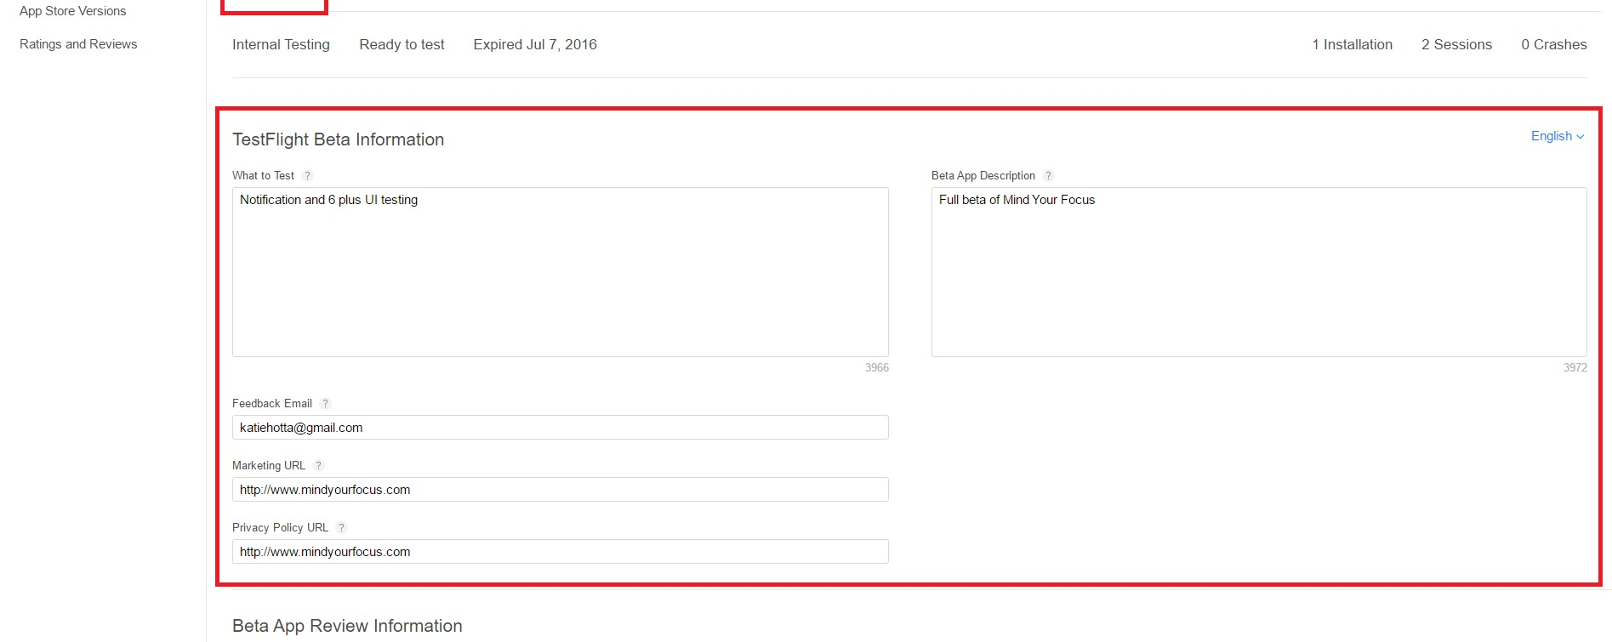
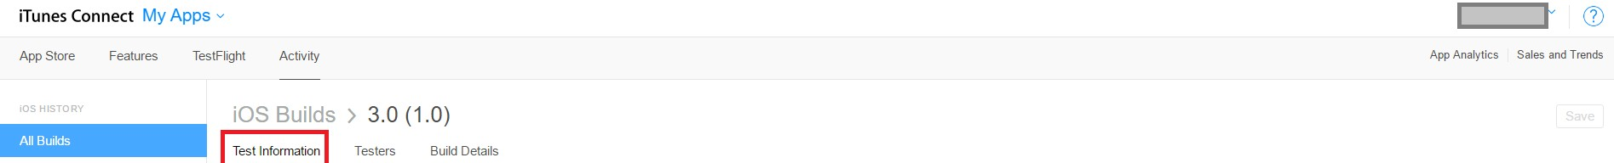

NOTE You don’t need to provide Beta App Review Information for internal testing

An iTunes Connect user that’s eligible to be an internal tester must be part of your iTunes Connect team with either the Admin, Technical, App Manager, Developer, or Marketer role. To assess what users have which roles, open the drop­down by clicking the drop­down illustrated below
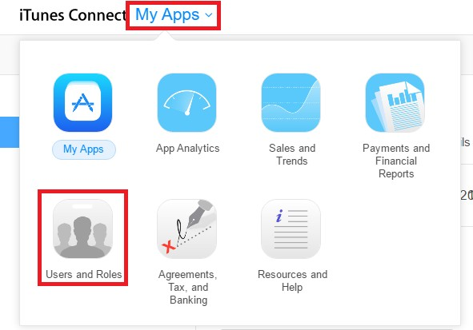

You can review each user's role underneath the Role column
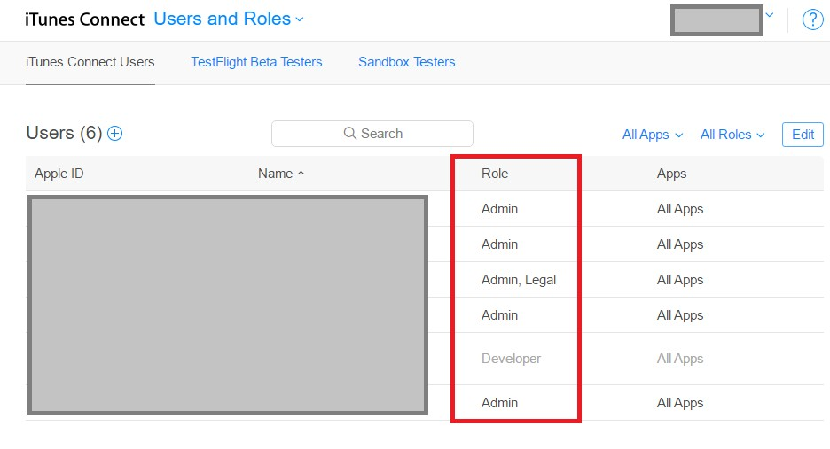

To add Internal testers, navigate back to your app in My Apps, select the TestFlight tab and click Internal Testing on the left­

hand side
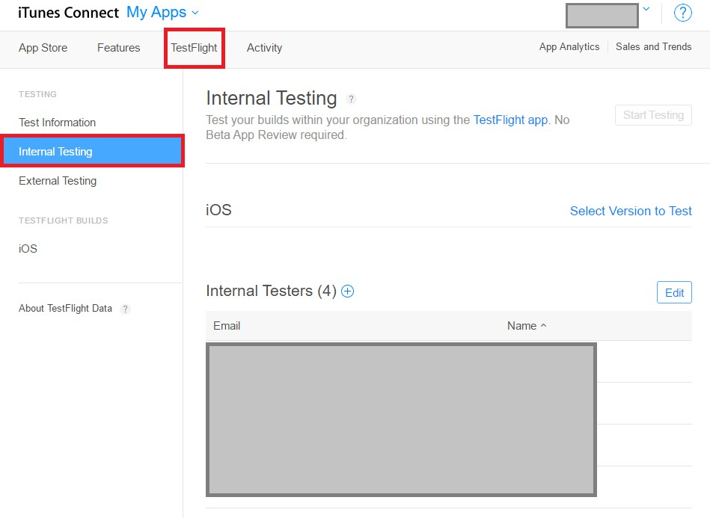

Now click the (+) sign next to the header Internal Testers

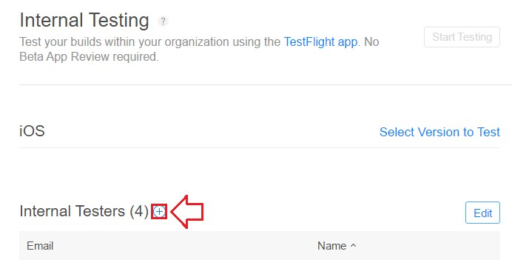

Check the box next to any eligible users who have not already been invited and click Add
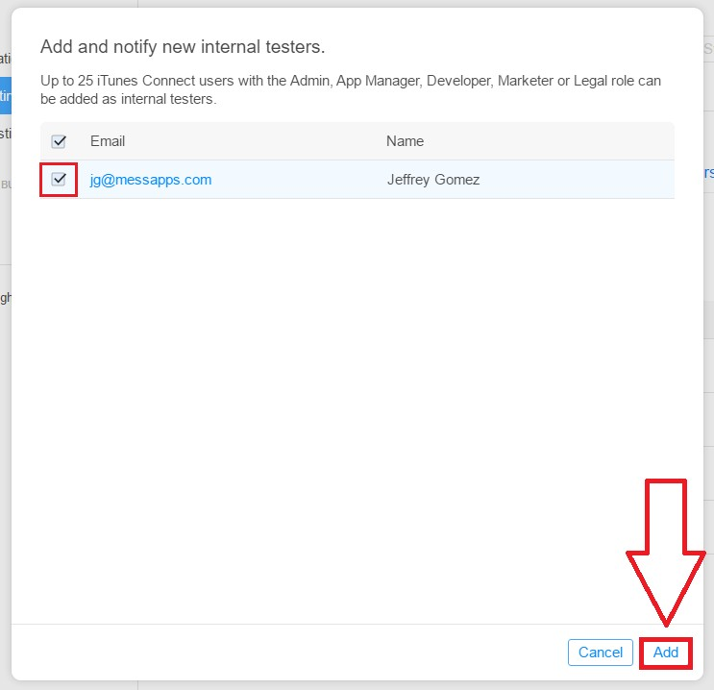

NOTE The current maximum capacity for testers is 25

Under the Internal Testing tab, click Select Version to Test

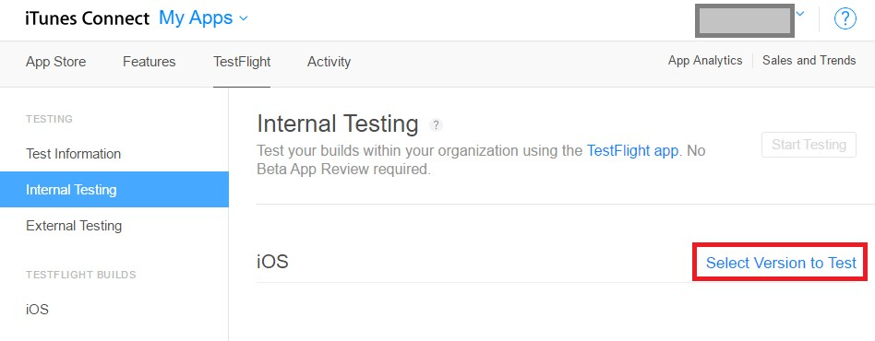

Select the Build to be tested and click Start Testing. Users you’ve previously selected for internal testing will automatically be emailed with both an attached invitation and a set of instructions for downloading the TestFlight app

0

You might also like this articles

David Murphy
25 June

Boost Your App’s Growth: Social
Implementations

Both Apple and Google trust that the amount of time users spend inside an app is indicative of its overall quality, and rank them accordingly.

0
Dominick Wojtas
31 July

What You Need To Do in the Pre-launch
Phase of Your App’s Life

Once you’ve entered the pre­launch phase in your app’s life, you must turn your attention over to marketing
and planning. This part of the process is crucial to the success of your app.

0

